1.
Prove by mathematical induction.

2.
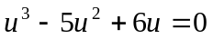 , 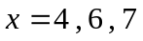

3.
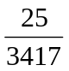

4.
(i) 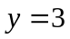 , 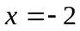
(iii) axial intercepts: 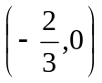 , 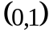

5.
(i) 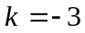
(ii) 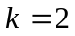 , 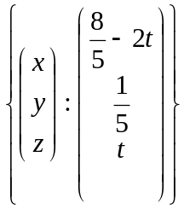
(iii) 